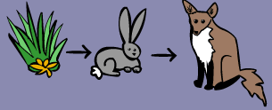
Food Chains and Food Webs

Name: ___________________________________

For this assessment you will need to write a report on food chains and food webs.

In the space below list some of the words you might expect to use when you are talking about the plant and food chains and food webs. _________________________________
________________________________________________________________________________________________________________________________________________________________________________________________________________________________________________________________________________________________________________________________________________________________________

In the space below make some notes on the things you know about the food chains. ________________________________________________________________________
________________________________________________________________________________________________________________________________________________________________________________________________________________________________________________________________________________________________________________________________________________________________________________________________________________________________________________________________________________________________________________________

In the space below make some notes on the things you know about food webs. _______
________________________________________________________________________________________________________________________________________________________________________________________________________________________________________________________________________________________________________________________________________________________________________________________________________________________________________________________________________________________________________________________________________________________________________________________________________________________________________________________________________________________________________________________________________________

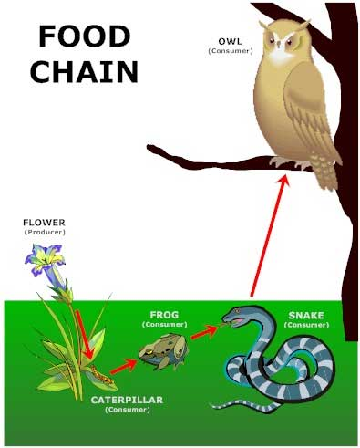
What do you know about the structure of a paragraph? ___________________________
_______________________________________________________
_______________________________________________________
_______________________________________________________
_______________________________________________________
_______________________________________________________
_______________________________________________________
_______________________________________________________

Introduction paragraph _____________________________________________________
________________________________________________________________________________________________________________________________________________________________________________________________________________________________________________________________________________________________________________________________________________________________________________________________________________________________________________
Food chains (look back at your notes on page one)
Topic sentence ___________________________________________________________
________________________________________________________________________________________________________________________________________________
Supporting sentences ______________________________________________________
________________________________________________________________________________________________________________________________________________________________________________________________________________________________________________________________________________________________________________________________________________________________________________________________________________________________________________________________________________________________________________________
________________________________________________________________________________________________________________________________________________
________________________________________________________________________
Food webs (look back at your notes on page one)
Topic sentence ___________________________________________________________
________________________________________________________________________________________________________________________________________________
Supporting sentences ______________________________________________________
________________________________________________________________________________________________________________________________________________________________________________________________________________________________________________________________________________________________________________________________________________________________________________________________________________________________________________________________________________________________________________________
________________________________________________________________________________________________________________________________________________
________________________________________________________________________

Conclusion ______________________________________________________________
________________________________________________________________________________________________________________________________________________________________________________________________________________________________________________________________________________________________________________________________________________________________________


